Bronze Layer Data Integration Patterns
Oct 19, 2026 · @Ravi R

Purpose and status
This document sets the standard patterns for ingesting data into the ADS Bronze layer, so that each source's pattern follows from its characteristics rather than from project preference. It is the first of the three architecture deliverables supporting the Data Mesh Target Architecture, owned initially by the integration workstream.
Audience: the architecture design authority (approval), delivery and data product teams (application), and the platform team (building the reusable framework components).
Status: draft for review. Statements are marked as follows:
- [Agreed] — decided in the Data Mesh TA meeting.
- [Proposed] — an architecture recommendation that extends or refines the meeting outcome and needs sign-off.
- [To confirm] — a requirement owned by another function (Security, Compliance, Legal, Risk).
In scope: ingestion from ODS and source systems into Bronze, including change detection, ingestion frequency, data landing, transport, and the standard controls every pattern carries. Out of scope: Silver and Gold modelling, consumption patterns, and reverse ETL.

Context: agreed direction
Most analytical data flows through the ODS before reaching Bronze; source systems feed Bronze directly only where no ODS exists. [Agreed]
- ODS → Bronze → Silver → Gold
- Source system → Bronze → Silver → Gold (where no ODS exists)
The meeting also agreed that:
- A dedicated Data Integration Framework is required for all Bronze ingestion, with security, resilience, governance and data quality delivered as reusable components, not rebuilt per project. [Agreed]
- ADS should not rely on repeated full refreshes; CDC or incremental loads are preferred. [Agreed]
- Every source system is classified against the patterns, with the rationale documented. [Agreed]
- Replay and reconciliation mechanisms are prescribed per pattern. [Agreed]
The target platform is Azure Data Lake Storage Gen2 with Delta Lake on Databricks, governed by Unity Catalog, with Kafka, Azure Event Hubs, IBM MQ and Azure Data Factory as integration services.
Refinement to the routing rule [Proposed]: a source with an ODS may still feed Bronze directly when the ODS cannot meet the consumer's audit, history or latency needs. An ODS typically overwrites in place, may not expose hard deletes, and adds a hop of latency, so Bronze built from it cannot prove what the source system originally recorded.

Design principles
Every pattern must satisfy these principles; a design that breaks one needs an approved exception.
- Bronze raw is immutable and append-only. [Proposed] Every snapshot, change record, event and file is kept as received. Nothing in Bronze raw is updated, merged or deleted except by retention policy. This is the basis for audit, replay and recovery.
- Merge happens downstream of Bronze raw. [Proposed] Current-state tables are derived from Bronze raw and can be rebuilt from it at any time.
- No transformation before Bronze. [Proposed] Cleansing, conforming and business logic belong in Silver. Upstream tools may only carry data, not change it.
- Bronze is the long-term replay source. [Proposed] Kafka retention and MQ dead-letter queues cover short outages; recovery beyond that window replays from Bronze.
- Prefer change-based over full extracts. [Agreed] CDC or incremental where the source allows; full extracts only where it does not.
- Freshness follows the consumer SLA. [Proposed] Use the cheapest ingestion frequency that meets the agreed freshness tier. Real-time is chosen, not defaulted to.
- Every pattern carries the standard controls. [Agreed] Security, resilience, governance and data quality come from the framework, not the project.
- One default tool per pattern. [Proposed] Alternatives need an approved exception, to limit tool sprawl.

Pattern model
A pattern is defined by one choice in each of three focus areas: change detection, ingestion frequency and data landing. Transport is an implementation attribute of the pattern, not a separate area. [Proposed]

Change detection — how changes are identified
Method | Use when | Limitation to manage
Log-based CDC | Source database exposes its transaction log; hard deletes or full history matter | Connector operations; initial-load-to-CDC cutover
Native events | Source publishes business events (Kafka, MQ) | Ordering, duplicates, schema contract
Incremental query | Source has a reliable change timestamp or sequence key and no hard deletes | Misses hard deletes; sensitive to clock skew and late commits
Incremental files | Source or partner delivers change files | Change semantics depend on the producer
Full snapshot | Source can only provide full extracts, or data is small reference data | Volume cost; deltas and deletes derived downstream

Ingestion frequency — how often data moves
Mode | Freshness tier | Typical latency
Real-time streaming | Tier 1 | Seconds
Micro-batch | Tier 2 | Up to 15 minutes
Scheduled batch | Tier 3 | Hourly
Daily batch | Tier 4 | T+1
All modes use the same streaming code where possible, run continuously or as a triggered run (availableNow). Moving a source between tiers then becomes a scheduling change, not a rebuild. [Proposed] The tier boundaries are a starting point. [To confirm] with the business.

Data landing — how data is written
Bronze has three zones. [Proposed]
Zone | Content | Write mode | Rebuildable
Landing | Files and payloads exactly as received | Write once | No — source of truth
Bronze raw | Delta table of every record received, plus the metadata envelope | Append only | From Landing
Bronze current state | Latest version of each entity, deletes applied | Merge | From Bronze raw
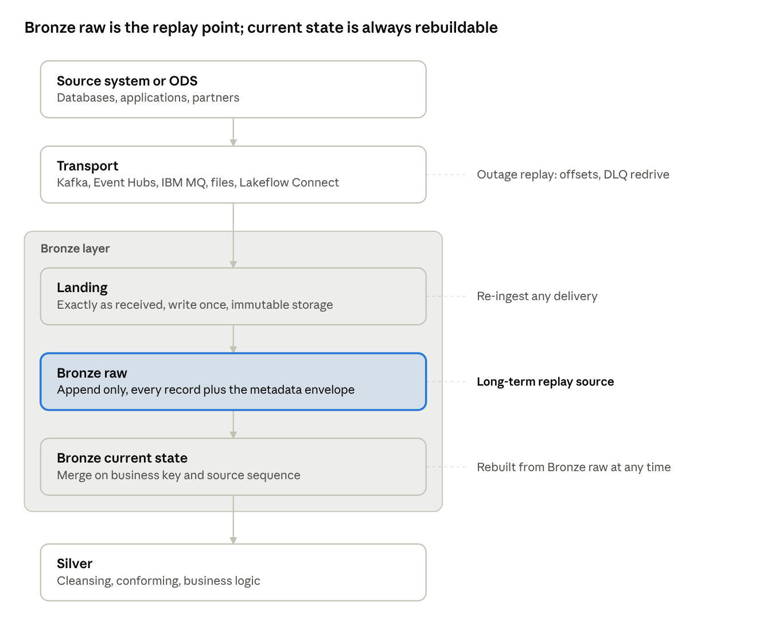
Bronze zones · from source to Silver
Landing is the irreplaceable copy for files; for event streams written straight to Delta, Bronze raw holds the payload as received and plays that role. Everything below it can be rebuilt, so recovery never depends on the source or on transport retention.
The landing choice then reduces to one question:
- Append events — the data is immutable events or transactions. Bronze raw is the final Bronze table.
- Merge changing entities — the data is mutable records (accounts, positions, reference data). Bronze raw is kept and a current-state table is derived by merge on business key and source sequence.

Transport — how data travels (pattern attribute)
- Event transport: Kafka, Azure Event Hubs, IBM MQ.
- File transport — push: the source delivers files to an ADS landing zone.
- File transport — pull: ADS retrieves files or queries the source on its own schedule.
- Managed connector: Lakeflow Connect reads the source directly.

Selecting a pattern
Each source is classified on seven dimensions; the decision tree below then fixes the choice in each focus area, so the pattern follows from the classification. [Proposed]

Selection dimensions
Dimension | Values
Route | ODS · Direct source
Data nature | Mutable entity · Immutable event · File or document
Source change capability | Log-based CDC · Native events · Reliable change timestamp · Incremental files · Full extract only
Delivery control | Source pushes · ADS pulls
Freshness tier | Tier 1 seconds · Tier 2 ≤ 15 min · Tier 3 hourly · Tier 4 T+1
Delete semantics | Hard deletes · Soft deletes · No deletes
Audit criticality | High · Standard
Two modifiers adjust the result without selecting it: volume and change rate (whether full extracts remain viable) and data sensitivity (PII handling in an immutable Bronze, see Standard controls).

Decision rules
Pattern — start at the top of the tree and answer each question about the source; the first pattern you reach is the one to use. Any source on a CDC, event or incremental pattern also uses Initial load and backfill when it is first onboarded.
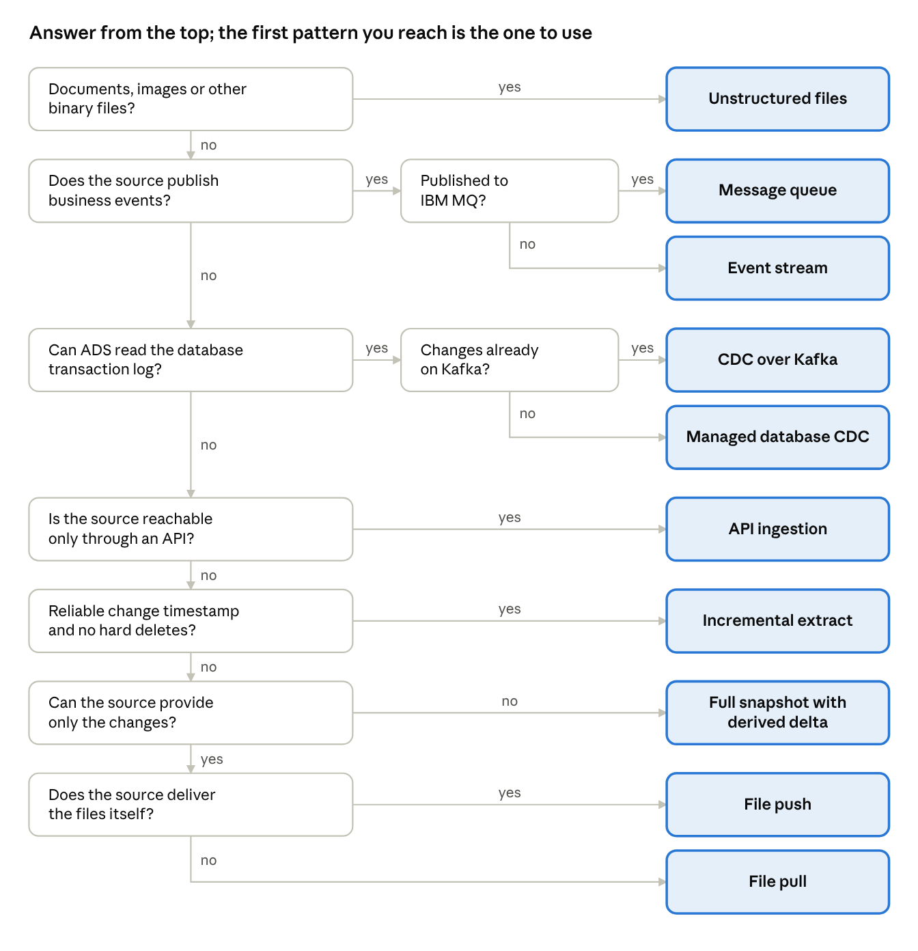
Pattern decision tree · 9 questions, 10 patterns
Ingestion frequency — the consumer's freshness tier, capped by what the change detection method supports. A full snapshot cannot exceed Tier 3; an incremental query rarely exceeds Tier 2.
Data landing — set by data nature: immutable events → Append events; mutable entities → Append + merge to current state; files → Append, then by content.
Transport — set by source change capability and delivery control: events and CDC streams → event transport; files → push or pull; supported databases and SaaS applications → Lakeflow Connect.
Route — if the source is reached through the ODS, apply the checks in Ingesting from the ODS below before confirming the pattern.
A classified source can be checked against the pattern catalogue: the four choices should match exactly one pattern. A source that matches none is an exception for the design authority.

Worked example: client account master (illustrative)
The client account master moves to Managed database CDC from the source database, with Initial load and backfill at onboarding. The classification runs as follows.
- Classify the source. Route: the ODS holds a copy. Data nature: mutable entity. Change capability: SQL Server with transaction log access. Delivery control: ADS pulls. Freshness tier: Tier 2 (15 minutes) for client reporting. Delete semantics: hard deletes when accounts close. Audit criticality: high.
- Check the route. The ODS overwrites accounts in place and does not pass closures through as deletes. With high audit criticality, the ODS checks fail, so the source is ingested directly.
- Walk the tree. Not binary files; no business events; the transaction log is readable; changes are not already on Kafka. Result: Managed database CDC.
- Confirm the focus areas. Change detection: log-based CDC. Frequency: Tier 2 → micro-batch. Landing: mutable entity → append to Bronze raw, merge to current state.
- Add the companion pattern. Initial load and backfill takes the first full snapshot and hands over to the change stream without a gap.
- Record it in the register with the rationale: direct route because the ODS loses deletes; CDC because of hard deletes and high audit criticality.

Ingesting from the ODS
Most sources reach Bronze through the ODS [Agreed], so the ODS is classified like any other source and the same decision tree gives its pattern. [Proposed] What differs is a set of checks on the ODS itself, because Bronze can only be as complete as the ODS copy.

Which pattern applies
What the ODS offers | Pattern
Database with transaction log access | Managed database CDC
Change stream already published to Kafka | CDC over Kafka
Tables with a reliable change timestamp and no hard deletes | Incremental extract
Scheduled extract files | File push or File pull
Full extracts only | Full snapshot with derived delta
Each also uses Initial load and backfill when first onboarded.

Checks before using the ODS route
- History. Does the ODS keep every change, or overwrite in place? If it overwrites, intermediate states between captures are lost.
- Deletes. Are source deletes passed through and visible as deletes?
- Latency. Does the source-to-ODS delay, plus the ODS-to-Bronze delay, still meet the freshness tier?
- Transformation. What does the ODS change (keys, codes, cleansing)? Record it, because Bronze lineage then starts at the ODS, not the source.
- Sequence. Does the ODS carry the original source commit time or sequence? If not, ordering relies on the ODS's own sequence.
- Ownership. Who owns ODS schema changes and outages, and how are they notified to ADS?

When to go direct instead
Ingest from the source directly when a check fails and audit criticality is high, or when the freshness tier cannot be met through the ODS. [Proposed]
For ODS-routed data, set _source_route to ODS and record the originating system in _source_system, so lineage shows both hops.

Pattern catalogue
Ten patterns cover the expected sources, plus one companion pattern for initial loads and backfills; each fixes the three focus areas and names one default toolchain. [Proposed] Default tools are a starting point [To confirm] with the platform team.
Pattern | Change detection | Frequency | Landing | Transport | Default toolchain
Managed database CDC | Log-based CDC | Micro-batch | Append + merge | Managed connector (pull) | Lakeflow Connect
CDC over Kafka | Log-based CDC | Streaming or micro-batch | Append + merge | Kafka | CDC tool → Kafka → Structured Streaming
Event stream | Native events | Streaming or micro-batch | Append events | Kafka or Event Hubs | Structured Streaming
Message queue | Native events | Streaming or micro-batch | Append events | IBM MQ | MQ → Kafka bridge, then as an event stream
Incremental extract | Incremental query | Batch or micro-batch | Append + merge | Pull | Azure Data Factory → Landing → Auto Loader
API ingestion | Incremental query or full snapshot | Batch or micro-batch | Append (+ merge for entities) | Pull | Lakeflow Connect, or Azure Data Factory → Landing → Auto Loader
File push | Incremental files or snapshot | Batch or micro-batch | Append (+ merge for entities) | Push | Source → Landing → Auto Loader
File pull | Incremental files or snapshot | Batch | Append (+ merge for entities) | Pull | Azure Data Factory → Landing → Auto Loader
Full snapshot with derived delta | Full snapshot | Batch | Append + derived delta + merge | Push or pull | File push or pull, then hash comparison in Lakeflow Declarative Pipelines
Unstructured files | New files | Batch or micro-batch | Append, one row per file | Push or pull | Unity Catalog volume → Auto Loader (binary files)
Initial load and backfill (companion) | Full snapshot, once | One-off | Append, then merge | As the main pattern | Main pattern's snapshot, or Azure Data Factory → Landing → Auto Loader
Bronze raw and current-state tables are built in Lakeflow Declarative Pipelines (formerly Delta Live Tables), with the current state applied by its CDC apply function sequenced on the source commit order. Lakeflow Jobs orchestrate; Unity Catalog governs access and lineage.

Pattern notes
Each pattern card is self-contained: purpose, the choice in each focus area, how it works, when to use it, what to watch for, replay and reconciliation, and an illustrative example. All standard controls apply to every pattern; a card lists only what is specific to it. In every diagram the highlighted box is Bronze raw, the long-term replay point.

Managed database CDC
The default for source databases that a managed connector supports: changes are read from the database's transaction log with the least build effort.
At a glance. Change detection: log-based CDC · Frequency: micro-batch · Landing: append + merge · Transport: managed connector (pull) · Toolchain: Lakeflow Connect.
How it works. Lakeflow Connect reads inserts, updates and deletes from the log and appends each change to Bronze raw with its commit sequence. A current-state table is then merged on business key, in sequence order.
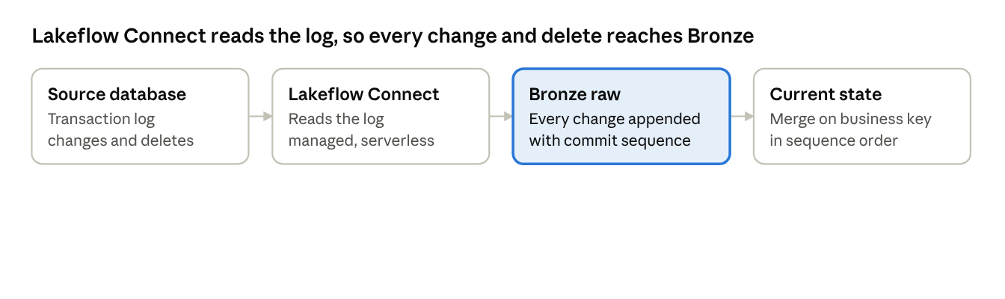
Managed database CDC · 4 steps
Use when. The source is a supported database, log access is granted, and hard deletes or full change history matter.
Watch for. Connector support per database version, load on the source, and a clean cutover from the initial load to the change stream.
Replay and reconciliation. After a short outage the connector resumes from its stored log position; beyond that, current state is rebuilt from Bronze raw. Reconcile row counts by key range, with a periodic full snapshot compare. Changes are merged by commit sequence, never by arrival time.
Example (illustrative). A client account master in SQL Server, where accounts are amended and closed during the day. Every amendment and closure is captured, and Silver reads the current state every 15 minutes.

CDC over Kafka
For sources whose change stream already flows through Kafka, or where several consumers need the same changes.
At a glance. Change detection: log-based CDC · Frequency: streaming or micro-batch · Landing: append + merge · Transport: Kafka · Toolchain: CDC tool → Kafka → Structured Streaming.
How it works. A CDC tool publishes each database change to a Kafka topic per table. Bronze subscribes to the topic like any other consumer, appends every change record, and merges a current-state table.
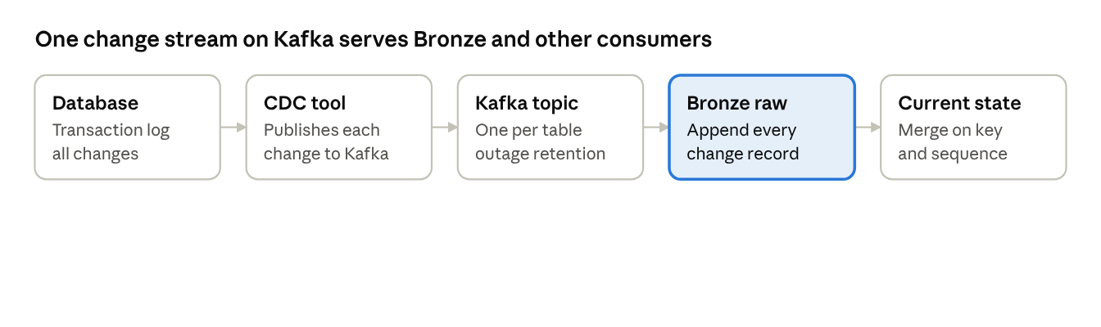
CDC over Kafka · 5 steps
Use when. A CDC tool and Kafka are already in place for the source, or another team also needs the change stream. This includes mainframe sources, where a CDC tool such as IBM CDC for z/OS publishes to Kafka.
Watch for. Topic ownership and schema contracts sit with the producing team. Kafka retention covers outages only; long-term replay is from Bronze raw.
Replay and reconciliation. Within Kafka retention, reset the consumer offset; beyond it, rebuild from Bronze raw. Reconcile Kafka offset ranges consumed against records landed, with a periodic snapshot compare. The producer keys each topic by primary key, so all changes to one row stay in order in one partition.
Example (illustrative). A positions database whose changes already feed a risk system through Kafka. Bronze subscribes to the same topics, so no second extract runs against the source.

Event stream
For applications that publish business events, which are facts that never change once they happen.
At a glance. Change detection: native events · Frequency: streaming or micro-batch · Landing: append events · Transport: Kafka or Event Hubs · Toolchain: Structured Streaming.
How it works. Events are published to Kafka or Event Hubs, partitioned by business key. Spark Structured Streaming writes them to a Bronze raw table per topic with exactly-once delivery, append only.
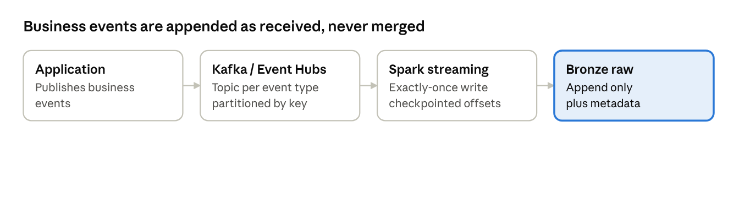
Event stream · 4 steps
Use when. The source emits events natively and consumers need seconds-to-minutes freshness.
Watch for. Ordering holds only within a partition, so producers must key by entity. Duplicates are removed on key and sequence.
Replay and reconciliation. Within retention, reset the consumer offset; beyond it, reprocess from Bronze raw. Reconcile offsets consumed against records landed, plus end-of-day control totals from the source.
Example (illustrative). Settlement status events (matched, settled, failed) from the settlement engine, used by an operational monitoring dashboard with seconds-level freshness.

Message queue [Proposed]
For applications that publish messages to IBM MQ, where a message is removed once consumed.
At a glance. Change detection: native events · Frequency: streaming or micro-batch · Landing: append events · Transport: IBM MQ bridged to Kafka · Toolchain: MQ source connector → Kafka → Structured Streaming.
How it works. By default an MQ source connector bridges the queue into Kafka, acknowledging each MQ message only after Kafka has written it. From there the message is ingested as an event stream. This gives one replay model, retention independent of queue depth, and lets several consumers read the same messages.
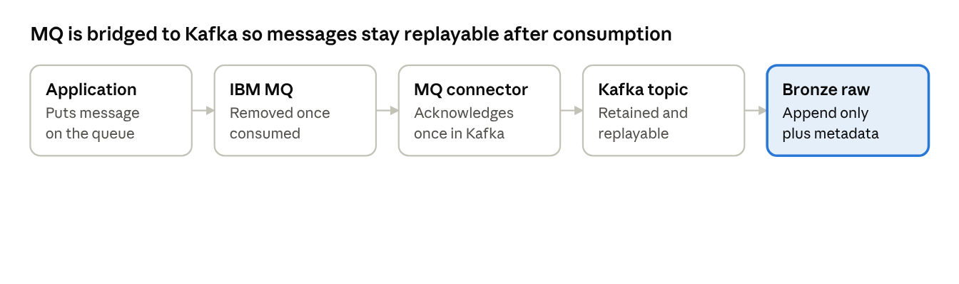
Message queue · 5 steps
Use when. The source publishes to IBM MQ.
Watch for. Direct MQ consumption, without the bridge, is an approved exception only, for example where the bridge would breach a latency requirement. A direct consumer must commit to Bronze before acknowledging each message, because the queue keeps no copy.
Replay and reconciliation. Once bridged, replay from Kafka offsets; messages that failed to bridge are redriven from the dead-letter queue. Beyond Kafka retention, reprocess from Bronze raw. Reconcile message counts and sequence gaps, plus the end-of-day reconciliation file.
Example (illustrative). Settlement instructions received over MQ, bridged to Kafka so that Bronze and the matching engine read the same replayable stream.

Incremental extract
For databases without log access but with a reliable change timestamp or sequence column.
At a glance. Change detection: incremental query · Frequency: batch or micro-batch · Landing: append + merge · Transport: pull · Toolchain: Azure Data Factory → Landing → Auto Loader.
How it works. Azure Data Factory queries rows changed since the last watermark and writes them as extract files to Landing. Auto Loader appends them to Bronze raw, and a current-state table is merged on business key.
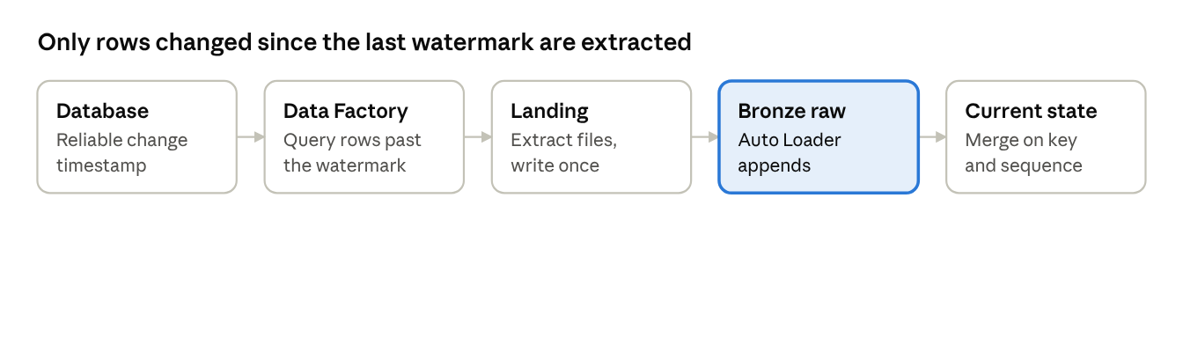
Incremental extract · 5 steps
Use when. Log-based CDC is not available, the change timestamp is trustworthy, and freshness of an hour or more is acceptable.
Watch for. Hard deletes are invisible to the query; if they can occur, add a periodic full key extract to detect them. The watermark must allow for late-committing transactions.
Replay and reconciliation. Rerun from the last committed watermark; long term, rebuild from Bronze raw. Reconcile counts and control totals per extract, and compare key sets to detect deletes.
Example (illustrative). A fee-billing database with a last-updated column on every table and no hard deletes, loaded hourly.

File push
For sources and partners that deliver files on their own schedule.
At a glance. Change detection: incremental files or snapshot · Frequency: batch or micro-batch · Landing: append (+ merge for entities) · Transport: push · Toolchain: Source → Landing → Auto Loader.
How it works. The source writes files and a manifest to an ADS landing zone under the landing contract (see Standard controls). Auto Loader starts only when the manifest arrives, checks counts and checksums, and appends to Bronze raw.
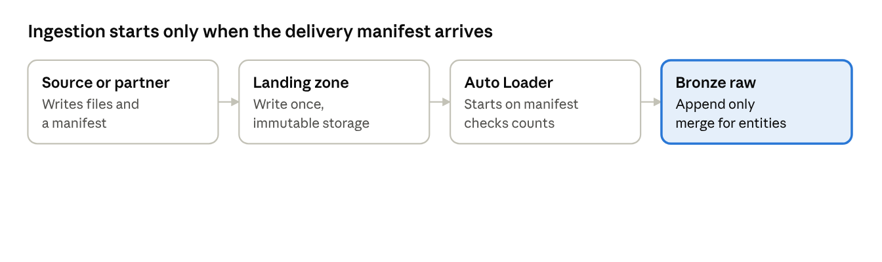
File push · 4 steps
Use when. The source controls when data is ready, or it is an external party that cannot be queried.
Watch for. Late or missing deliveries must be detected by an expected-delivery check, not by waiting. Corrections arrive as new deliveries, never as overwritten files.
Replay and reconciliation. Re-ingest any delivery from Landing. Reconcile the manifest's file counts, row counts and checksums against what landed.
Example (illustrative). A custodian pushes a daily corporate-actions file with a manifest after its end-of-day close.

File pull
For sources that expose files but do not deliver them.
At a glance. Change detection: incremental files or snapshot · Frequency: batch · Landing: append (+ merge for entities) · Transport: pull · Toolchain: Azure Data Factory → Landing → Auto Loader.
How it works. Azure Data Factory collects files from the source location on an ADS schedule, using an ADS identity, and writes them to Landing. Auto Loader appends them to Bronze raw.
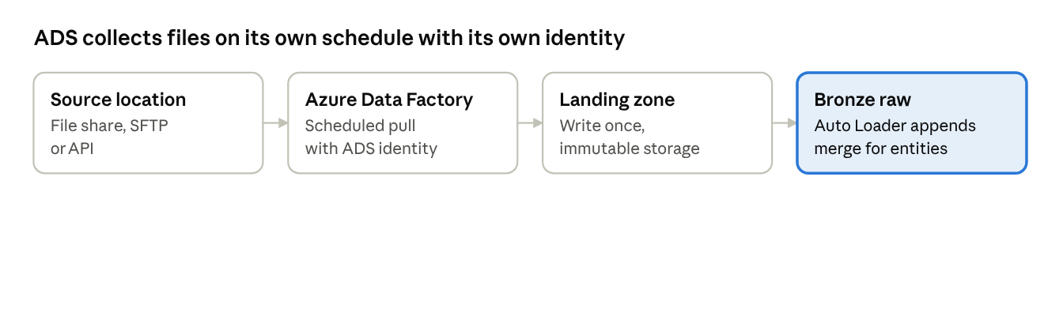
File pull · 4 steps
Use when. ADS controls the schedule, and the source offers a file share, SFTP location or API.
Watch for. The source may still be writing a file when it is pulled; agree a completion signal or a stable naming convention. Credentials to the source are managed by ADS.
Replay and reconciliation. Re-ingest from Landing, or re-pull from the source if it still holds the files. Reconcile file counts, row counts and checksums against the source listing.
Example (illustrative). A market data vendor's price files, collected nightly from the vendor's SFTP location.

Full snapshot with derived delta [Proposed]
For sources that can only provide full extracts. It implements the agreed read-before-write capability without breaking an immutable Bronze.
At a glance. Change detection: full snapshot · Frequency: batch · Landing: append + derived delta + merge · Transport: push or pull · Toolchain: file push or pull, then hash comparison in Lakeflow Declarative Pipelines.
How it works. Each full extract lands whole in Bronze raw. A row hash per business key is compared with the current state to identify new, changed and deleted rows, and only those are merged.
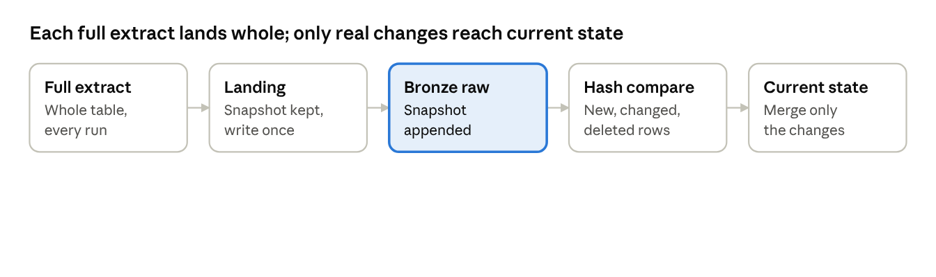
Full snapshot with derived delta · 5 steps
Use when. No log, timestamp or change file is available, and the table is small enough to extract in full at the required frequency.
Watch for. Storage grows with every snapshot, so keep full snapshots for an agreed period and the derived changes longer. A partial extract would look like mass deletes; reconcile the row count before applying deletes.
Replay and reconciliation. Re-ingest a snapshot from Landing, or recompute the deltas from Bronze raw. Reconcile the snapshot's row count and control totals against current state before applying deletes.
Example (illustrative). A legacy counterparty system that exports its full counterparty table nightly.

API ingestion
For SaaS applications and services that expose their data only through an API.
At a glance. Change detection: incremental query (a changed-since filter) or full snapshot · Frequency: batch or micro-batch · Landing: append (+ merge for entities) · Transport: pull · Toolchain: Lakeflow Connect where a connector exists, otherwise Azure Data Factory → Landing → Auto Loader.
How it works. ADS calls the API on a schedule, asking for records changed since the last watermark where the API supports it. Each response is written unchanged to Landing as raw JSON, then appended to Bronze raw. A source that pushes events by webhook is treated as an event stream, through Event Hubs.
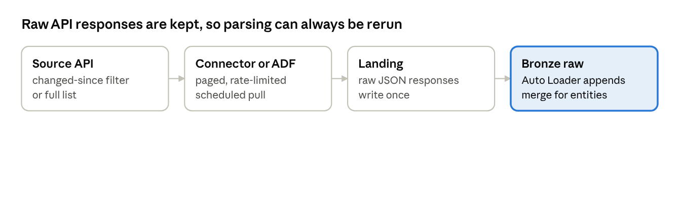
API ingestion · 4 steps
Use when. The source offers no database access, no events and no file delivery.
Watch for. Rate limits and paging. Many APIs do not expose deletes, so a periodic full list is needed to detect them. API versions change, and raw responses are kept so parsing can be rerun.
Replay and reconciliation. Re-ingest from Landing; call the API again only if the source still holds the history. Reconcile record counts against totals the API reports, with a periodic full-list compare.
Example (illustrative). A SaaS CRM holding client contacts, pulled every 15 minutes through its API.

Unstructured files
For documents, images, PDFs, emails and other binary content.
At a glance. Change detection: new files · Frequency: batch or micro-batch · Landing: append, one row per file · Transport: push or pull · Toolchain: Landing in a Unity Catalog volume → Auto Loader in binary file mode.
How it works. Files land unchanged in a Unity Catalog volume. Auto Loader writes one Bronze raw row per file with its path, size, checksum, content type and source metadata, not its parsed content. Text extraction, OCR and classification happen in Silver.
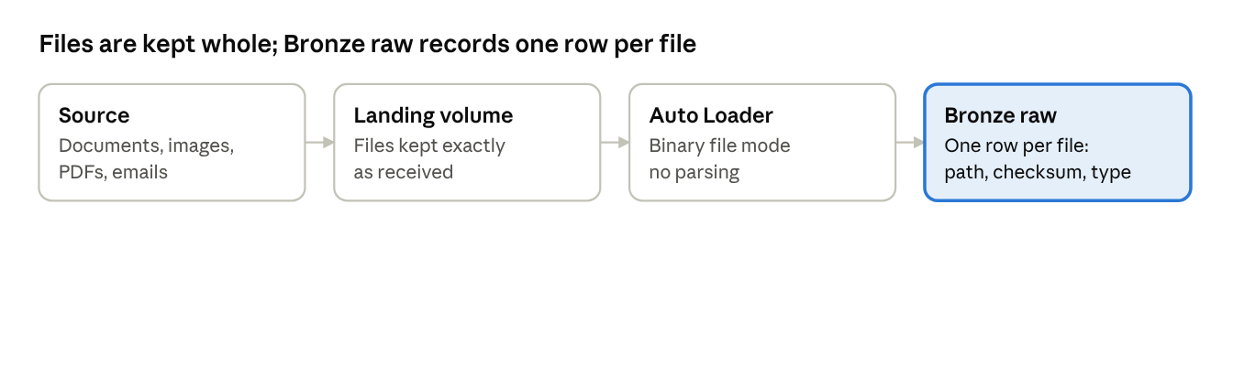
Unstructured files · 4 steps
Use when. Content must be retained or analysed, for example for search or document AI.
Watch for. Large files, personal data inside documents (classify before granting wide access), and retention rules that differ by document type.
Replay and reconciliation. Reprocess from Landing. Reconcile file counts and checksums against the manifest or the source listing.
Example (illustrative). Scanned legal agreements and client correspondence as PDFs, landed for search and document AI.

Initial load and backfill [Proposed]
A companion to every change-based pattern: it loads existing data once, and reloads history when needed, without gaps or duplicates against the change stream.
At a glance. Change detection: full snapshot, once or on demand · Frequency: one-off · Landing: append, then merge · Toolchain: the main pattern's initial snapshot (Lakeflow Connect), or Azure Data Factory → Landing → Auto Loader.
How it works. Start change capture first and record the source position (log sequence or Kafka offset) where it began. Then take a consistent snapshot of the source, land it whole in Bronze raw marked as a snapshot, and apply it to current state. Changes from the recorded position onwards are applied on top in sequence. Because merges are idempotent on business key and sequence, any overlap between the snapshot and the changes is harmless.
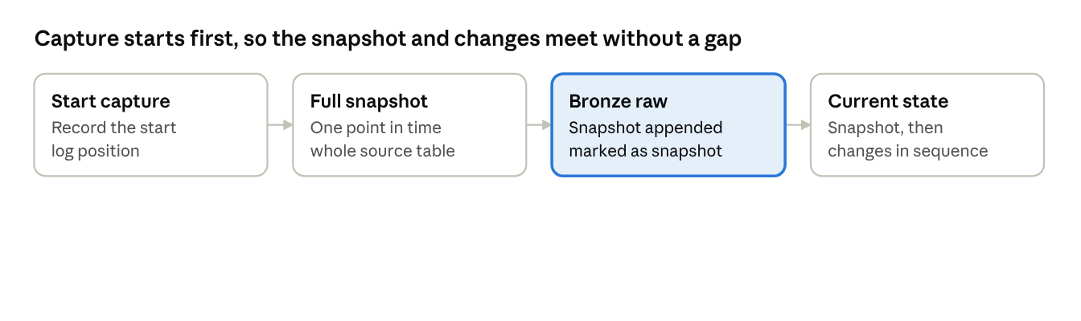
Initial load and backfill · 4 steps
Use when. Onboarding a source on any CDC, event or incremental pattern; recovering after an outage longer than transport retention; correcting history.
Watch for. The snapshot must be consistent to one point in time. Load large tables in partitions and throttle the load on the source. History the source no longer holds cannot be backfilled; Bronze raw is then the only record.
Replay and reconciliation. Rerun from Landing. Reconcile the snapshot's row count and control totals against the source at the recorded position.
Example (illustrative). Onboarding the client account master: change capture starts at 18:00, a full snapshot is taken at 18:05, and changes are applied from the 18:00 position onwards.

Standard controls
Every pattern inherits the controls below from the framework; projects configure them but do not rebuild them. [Agreed] The specific mechanisms are [Proposed].
Area | Control | Framework mechanism
Security | Authentication | Managed identities or service principals in Entra ID; no shared credentials; secrets in Key Vault
Security | Authorization | Unity Catalog grants per zone; write access to Bronze only for the ingestion identity
Security | Network | Private endpoints to sources, Kafka and storage
Resilience | Error handling | Malformed records routed to a quarantine table with the reason, never dropped
Resilience | Retry | Bounded retries with back-off; failure alerts after the last attempt
Resilience | Replay | Per pattern, from Bronze raw beyond the transport's retention (see Replay and reconciliation)
Resilience | Backup and archive | Delta time travel for short-term recovery; Landing zone on immutable storage; tiered retention
Governance | Audit trail | Metadata envelope on every record; Unity Catalog lineage and audit logs
Governance | Reconciliation | Per pattern (see Replay and reconciliation)
Data quality | Source-to-target verification | Counts and control totals per load
Data quality | Completeness | End-to-end checks against expected loads, files or offsets

Metadata envelope
Every Bronze raw record carries these columns. [Proposed]
Column | Content
_ingest_ts | Time the record was written to Bronze
_source_system | Source system identifier
_source_route | ODS or direct
_batch_id | Load, file or micro-batch identifier
_source_seq | Source commit sequence (LSN, SCN) or Kafka partition and offset
_op | Operation: insert, update, delete, snapshot
_source_ts | Source commit or event time
_schema_version | Version of the source schema contract
_file_name | Source file, for file patterns
_row_hash | Hash of the business payload, for change detection and deduplication

Push landing contract
For the file push pattern, and full snapshots delivered by push, sources must:
- Write to the agreed landing path using their own identity.
- Publish a manifest or completion marker after each delivery, listing files, row counts and checksums. Ingestion starts only on the marker, so partial files are never read.
- Never overwrite or rename a delivered file; corrections are new deliveries.

Schema evolution
New columns are added automatically and alerted. Type changes and dropped columns stop the pipeline for review. Each change increments _schema_version. [Proposed]

Personal data in an immutable Bronze
An immutable Bronze can conflict with erasure obligations under GDPR. The options are tokenizing personal data at ingestion, encrypting it with per-subject keys that can be destroyed, or limiting Bronze retention for those fields. [To confirm] with Data Protection and Legal before any personal data is ingested.

Replay and reconciliation
Replay has two tiers: the transport covers short outages, and Bronze raw covers everything after that. [Proposed] The meeting's 7-day Kafka retention is enough for the first tier, not for audit or reprocessing months later.
Each pattern card states its own short-term replay, long-term replay and reconciliation. The rules below apply to every pattern.

Rules
- Land, then acknowledge. [Proposed] For MQ and any transport that deletes on consumption, a message is acknowledged only after it is committed to Bronze raw.
- Idempotent writes. [Proposed] Every pipeline can be rerun safely. Duplicates are removed on business key plus _source_seq.
- Retention. [To confirm] Kafka at least 7 days, dead-letter queues long enough to cover a weekend outage, and Bronze raw and Landing per the regulatory record-keeping periods (DORA, CSDR and internal policy) set by Compliance.
- End-of-day reconciliation. [Agreed] Event patterns reconcile daily against source-provided control files or Kafka-derived reconciliation datasets. A break raises an incident and blocks downstream publication for the affected data [Proposed].

Event ordering and late data
Bronze raw stores records in arrival order and never reorders them; order is restored when current state is derived, using the source sequence carried on each record. [Proposed] The answers below address the four questions raised in the meeting.
Question from the meeting | Standard
How to preserve source transaction sequence? | Producers partition by business key, so all changes to one entity stay in one partition in order. Every record carries the source commit sequence (_source_seq: LSN, SCN or a producer sequence number).
How to handle late-arriving events? | Bronze raw accepts them whenever they arrive. Current state applies a change only if its sequence is newer than the stored one, so a late older change cannot overwrite a newer one. Time-windowed aggregates in Silver use watermarks with an agreed lateness bound.
How to process out-of-order messages? | Merge by _source_seq, never by arrival time or _ingest_ts. The CDC apply function in Lakeflow Declarative Pipelines does this when sequenced on that column.
How to ensure Bronze maintains data consistency? | Exactly-once writes from Structured Streaming checkpoints, idempotent merges keyed on business key and sequence, and the per-pattern reconciliation.

Ordering across queues and Kafka nodes
Global order across topics, partitions or queues is not guaranteed and must not be required. [Proposed] Where a business process depends on order across entities (for example, an instruction and its later amendment), the producer must publish both to the same key or carry a shared sequence. This is a producer design requirement, and the source classification register records whether each source meets it.

Source classification register
Each source gets one row, classified on the seven selection dimensions, with its pattern and the rationale; this is the register the meeting asked for. [Agreed] The first row is an illustrative example, not a real classification.
Source | Route | Data nature | Change capability | Delivery control | Freshness tier | Deletes | Audit criticality | Pattern | Replay and recon | Rationale | Owner
Example: settlement instructions | Direct | Immutable event | Native events | Source pushes | Tier 2 | None | High | Message queue | DLQ redrive; Bronze raw; end-of-day file | Events published to MQ; high criticality needs source fidelity, so direct rather than via ODS | —
A row is complete when every dimension is filled, the pattern matches the decision tree, and any deviation is recorded as an exception with its approval.

Glossary
Term | Meaning
Auto Loader | Databricks feature that detects new files in cloud storage and loads each one exactly once.
availableNow | A Structured Streaming trigger that processes everything available, then stops; it lets streaming code run as a scheduled batch.
Bronze current state | A table holding the latest version of each entity, derived from Bronze raw by merge; it can be rebuilt at any time.
Bronze raw | The append-only Delta table of every record received, plus the metadata envelope; the long-term replay source.
CDC (change data capture) | Capturing inserts, updates and deletes from a database, usually by reading its transaction log.
CDC apply function | The Lakeflow Declarative Pipelines function that merges change records into a current-state table in sequence order.
Commit sequence (LSN, SCN) | The position of a change in the database transaction log: LSN in SQL Server, SCN in Oracle. It gives the true order of changes.
Dead-letter queue (DLQ) | A queue holding messages that failed processing, so they can be inspected and redriven.
Exactly-once | A guarantee that each record is written once, even after failures and retries.
Freshness tier | The agreed maximum delay between a change at the source and its arrival in Bronze.
Idempotent | An operation that gives the same result however many times it runs, so reruns are safe.
Kafka offset and partition | A topic is split into partitions; the offset is a record's position in its partition, used to resume and replay.
Lakeflow Connect | Databricks managed connectors that ingest from databases and SaaS applications.
Lakeflow Declarative Pipelines | Databricks framework for building pipelines declaratively; formerly Delta Live Tables.
Landing | The zone where files and payloads are stored exactly as received, write once.
Manifest | A file a source delivers alongside its data, listing files, row counts and checksums, and signalling that a delivery is complete.
Metadata envelope | The standard columns added to every Bronze raw record (see Standard controls).
ODS (operational data store) | An integrated, near-current copy of operational data that sits between source systems and ADS.
Row hash | A hash of a record's business columns, used to detect whether it changed between snapshots.
Structured Streaming | Spark's engine for incremental and streaming processing, with checkpoints for exactly-once delivery.
Unity Catalog | Databricks governance layer for access control, lineage and auditing.
Watermark | The last change timestamp or sequence successfully loaded; the next incremental extract starts from it.

Open decisions and next steps
Five proposals need a design authority decision before the framework build starts; the remaining items are confirmations from other functions.
Decisions for the design authority
- ☐ Adopt immutable, append-only Bronze raw, with merge only into a derived current-state table.
- ☐ Allow direct-from-source ingestion where an ODS exists but cannot meet audit, history or latency needs.
- ☐ Make Bronze raw the long-term replay source, with Kafka and dead-letter queues as short-term buffers.
- ☐ Bridge IBM MQ into Kafka by default, with land-then-acknowledge for approved direct MQ consumers.
- ☐ Approve the pattern catalogue and one default toolchain per pattern.
Confirmations from other functions
- ☐ Compliance: retention periods for Landing, Bronze raw, Kafka and dead-letter queues.
- ☐ Data Protection and Legal: approach to personal data in an immutable Bronze.
- ☐ Security: identity, network and Key Vault standards for each transport.
- ☐ Business owners: freshness tier boundaries.
- ☐ Platform team: default tools, connector support for the main source databases, and the CDC tool for P2.
Next steps
- ☐ Classify the first wave of sources in the register to test the decision rules.
- ☐ Build the managed database CDC, event stream and file push patterns first as reference implementations of the framework components.

